CYBERSECURITY PRACTICAL LAB

Cybersecurity Virtual Lab Setup
Lab Setup Report

Student Name
Course
Roll No.
Date

LAB COMPONENTS

Component | Purpose
Kali Linux | Security testing workstation
Metasploitable 2 | Intentionally vulnerable target VM
VMware Workstation | Virtualization platform
Wireshark | Network packet capture and analysis

Introduction
This lab establishes an isolated cybersecurity testing environment consisting of Kali Linux and Metasploitable 2. Kali Linux is used as the security testing workstation, while Metasploitable 2 acts as an intentionally vulnerable target system. Wireshark is used to capture and analyze network traffic generated during connectivity tests. The environment provides a controlled platform for learning Linux administration, network reconnaissance, vulnerability assessment, exploitation, and incident analysis.

Lab Objectives
The objectives are to configure two virtual machines on an isolated network, verify IP connectivity, perform basic service discovery, and capture test traffic using Wireshark.

Recommended Network Topology
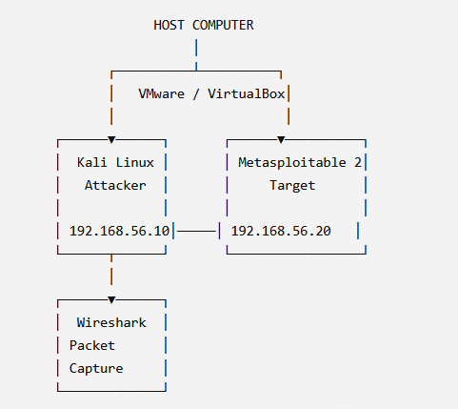
Figure 1 — Isolated lab topology

Safety Note
Metasploitable 2 is intentionally vulnerable. It should remain on an isolated host-only/internal network and should not be exposed directly to an untrusted or production network.

Step 1 — Install / Configure Kali Linux
Start the Kali Linux virtual machine and verify the operating system, kernel, current user, and network configuration.

Verify Operating System
cat /etc/os-release

Output:
PRETTY_NAME="Kali GNU/Linux Rolling" NAME="Kali GNU/Linux" VERSION_ID="2026.x"
ID=kali ID_LIKE=Debian

Check Kernel
uname -a

Check Current User
Whoami

Output:
Student

Check IP Configuration
ip addr
# or

ip a

Lab address used in this report: 192.168.56.10/24

Screenshot Evidence
Screenshot 1 — Kali Linux Desktop
Evidence placeholder: Screenshot showing the Kali desktop, terminal, and date/time.
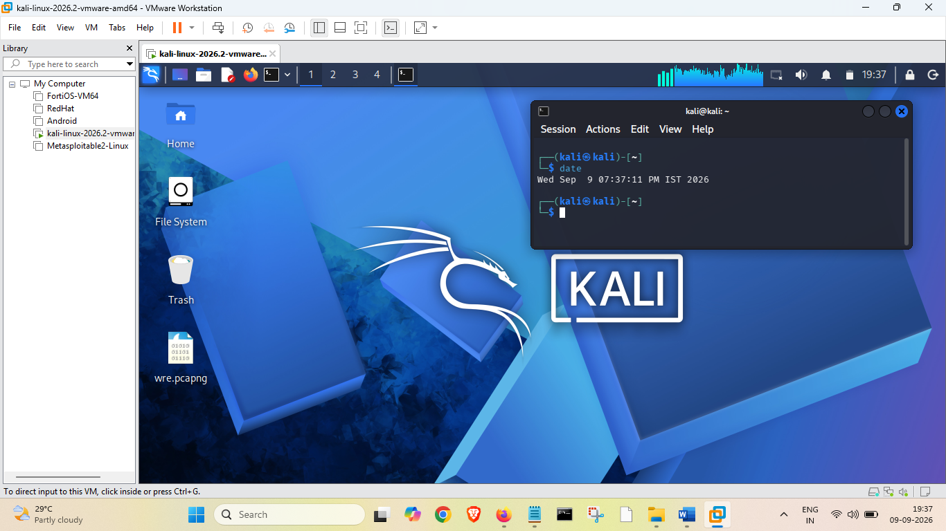

Screenshot 2 — Kali IP Configuration

Evidence placeholder: Terminal screenshot showing the output of ip addr and the lab IP address.

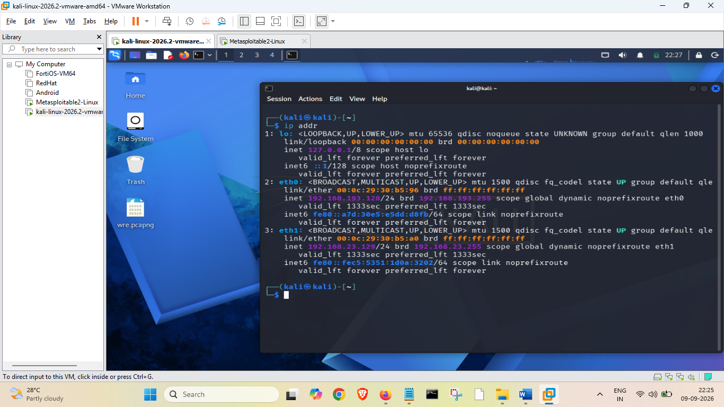

Step 2 — Configure Metasploitable 2
Start the Metasploitable 2 VM. After login, identify the network interface and verify the routing configuration.

Identify Network Interface
ifconfig # or
ip addr
Lab address used in this report: 192.168.56.20/24

Check Routing
route -n # or
ip route

Screenshot Evidence

Screenshot 3 — Metasploitable Login
Evidence placeholder: Screenshot of the Metasploitable console after successful login.
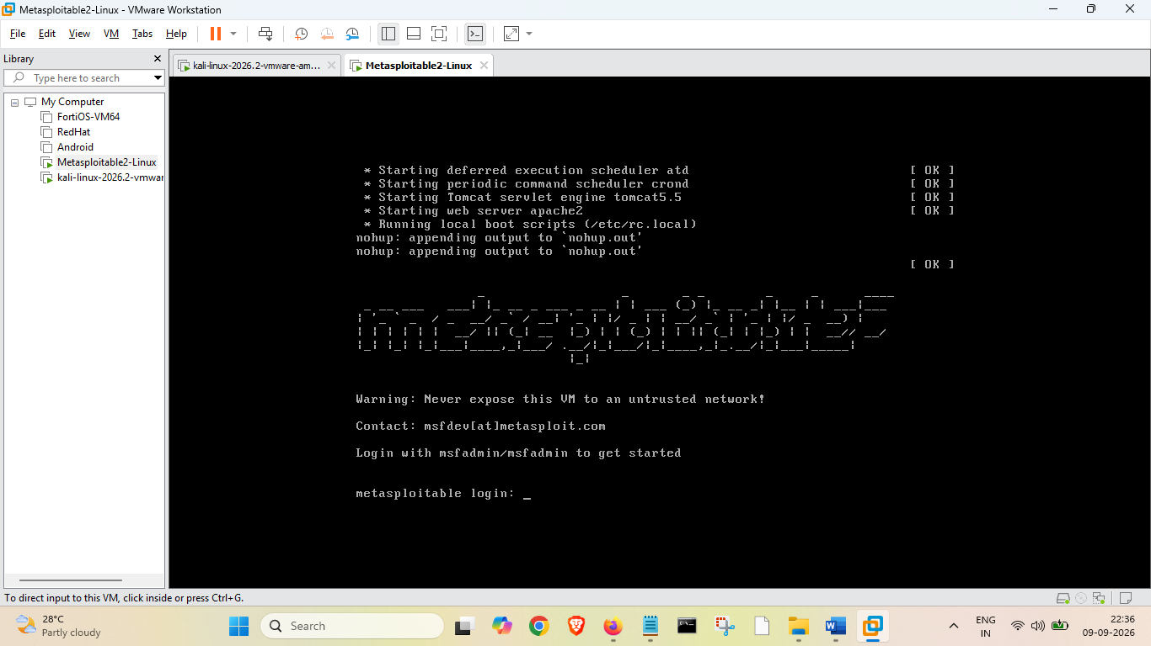
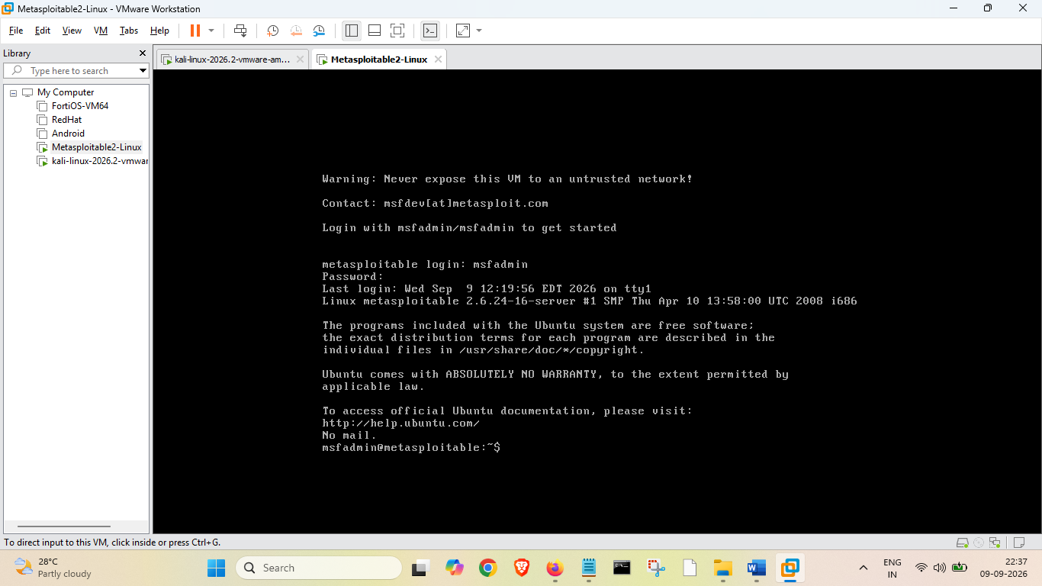

Screenshot 4 — Metasploitable Network Configuration

Evidence placeholder: Output of ifconfig or ip addr showing the assigned address.
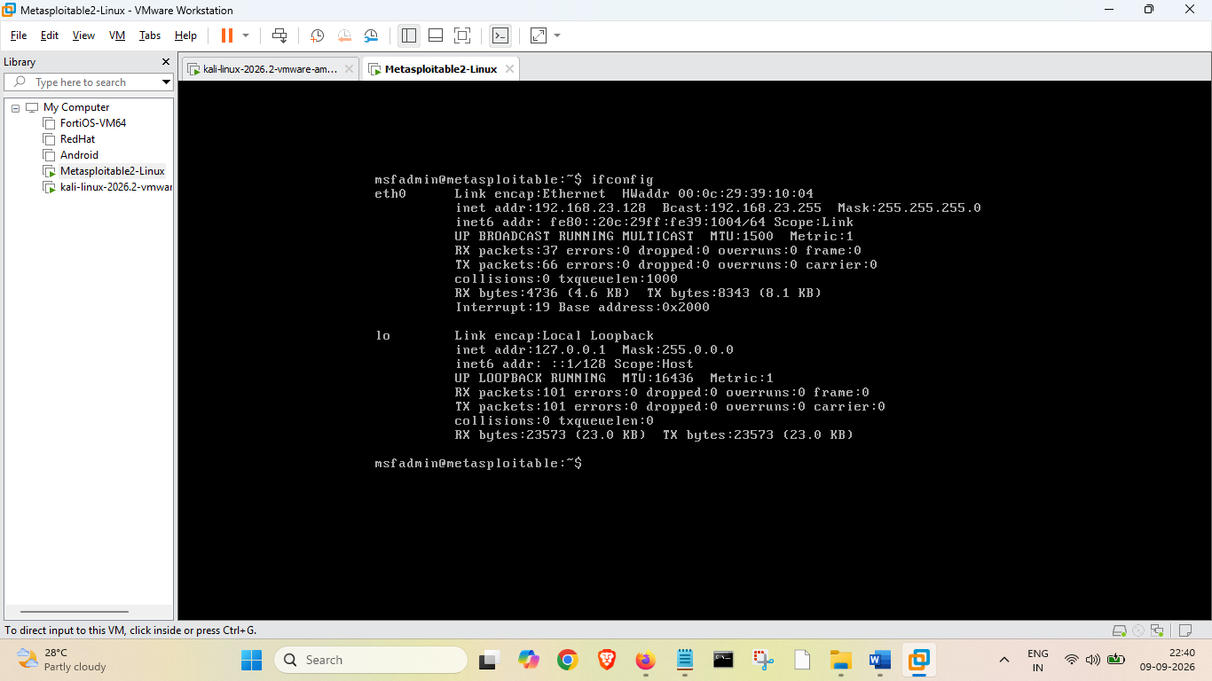

Step 3 — Verify Network Connectivity
From Kali Linux, send four ICMP echo requests to the Metasploitable 2 VM. A successful response confirms basic network-layer connectivity between the two laboratory systems.

Ping Test
ping -c 7 192.168.23.128

Output:

PING 192.168.23.128 (192.168.23.128) 56(84) bytes of data.

64 bytes from 192.168.23.128: icmp_seq=1 ttl=64 time=38.5 ms

64 bytes from 192.168.23.128: icmp_seq=2 ttl=64 time=1.23 ms

64 bytes from 192.168.23.128: icmp_seq=3 ttl=64 time=30.3 ms

64 bytes from 192.168.23.128: icmp_seq=4 ttl=64 time=2.06 ms

64 bytes from 192.168.23.128: icmp_seq=5 ttl=64 time=1.83 ms

64 bytes from 192.168.23.128: icmp_seq=6 ttl=64 time=1.68 ms

64 bytes from 192.168.23.128: icmp_seq=7 ttl=64 time=1.94 ms

--- 192.168.23.128 ping statistics ---

7 packets transmitted, 7 received, 0% packet loss, time 6664ms

rtt min/avg/max/mdev = 1.233/11.073/38.503/14.910 ms

Interpretation
The sample result shows seven replies and 0% packet loss. This indicates that Kali can successfully reach Metasploitable 2 over the isolated virtual network.

Screenshot 5 — Kali → Metasploitable Ping
Evidence placeholder: Screenshot showing the Kali terminal, destination IP, successful replies, and packet-loss statistics.

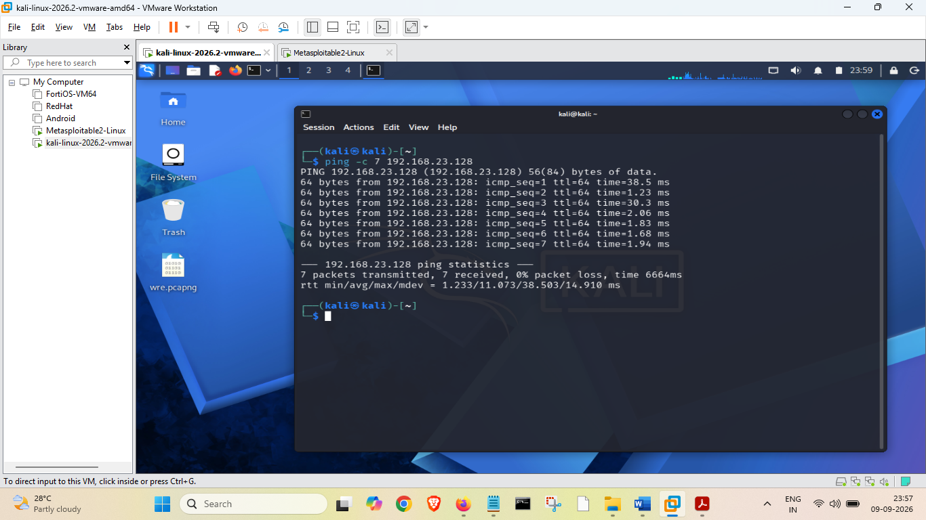

Step 4 — Wireshark Test Capture
Launch Wireshark on Kali Linux, select the interface connected to the isolated lab network, and start a packet capture.
wireshark
Generate ICMP traffic from Kali:
ping -c 7 192.168.23.128
Apply the Wireshark display filter:
icmp
The capture should contain ICMP Echo Request and Echo Reply packets. Stop the capture and save it as task1_wireshark_test_capture.pcapng.

Screenshot 6 — Wireshark ICMP Capture
Evidence placeholder: Screenshot showing the ICMP filter and captured packets.

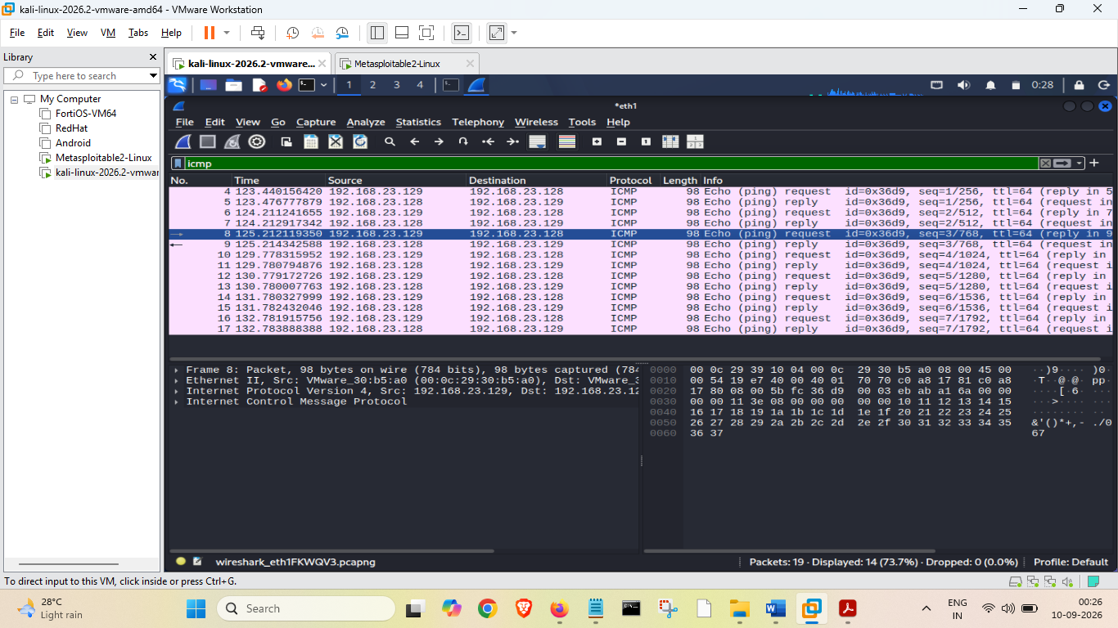

Conclusion
The sample laboratory configuration demonstrates the essential setup and verification stages for an isolated cybersecurity practice environment. Kali Linux provides the security-testing workstation, Metasploitable 2 provides a deliberately vulnerable target, and Wireshark provides packet-level visibility. Successful connectivity testing establishes a foundation for later reconnaissance, vulnerability assessment, exploitation, and incident-response exercises.

